1. **Cash Management (Responsibility Cash Management Super User ~ Setting terlebuh dahulu SLA User Management)**

**Setup > System > System Parameters**

* TAB -> System Controls

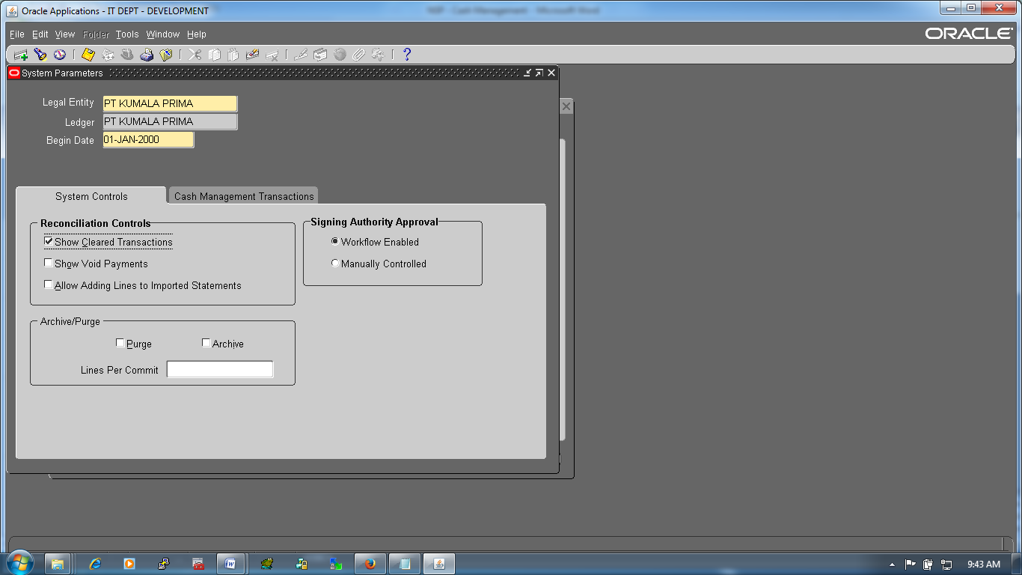

|  |  |  |
| --- | --- | --- |
| Legal Entry | : | PT. KUMALA PRIMA |
| Ledger | : | PT. KUMALA PRIMA |
| Begin Date | : | 01-JAN-2000 |
|  |  |  |
| Show Cleaned Transaction | : | Yes |
| Show Void Payment | : | No |
| Allow Adding Line to Imported Statments | : | No |
|  | : |  |
| Workflow Enabled | : | Yes |
| Manually Controlled |  | No |
|  |  |  |
| Purge | : | No |
| Archive | : | No |
| Line Per Coomit | : | Null |

* TAB -> Cash Management Transaction

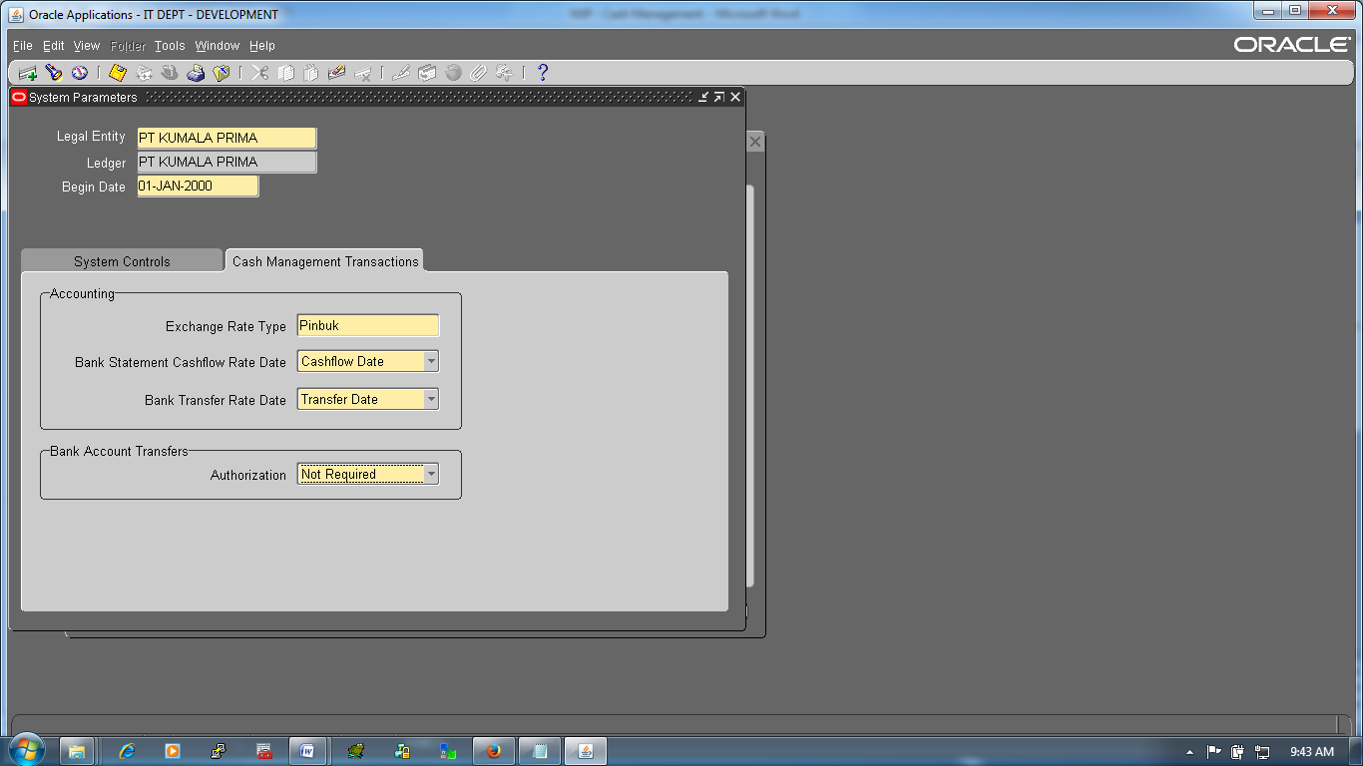

|  |  |  |
| --- | --- | --- |
| Exchange Rate Type | : | Pinbuk |
| Bank Statement Casflow Rate Date | : | Cashflow Date |
| Blank Transfer Rate Date | : | Transfer Date |
|  | : |  |
| Authorization | : | Not Required |

1. **Cash Management: Define Security Wizard (Responsibility User Management)**

Roles & Role Inheritance 🡪Search Application: Cash Management 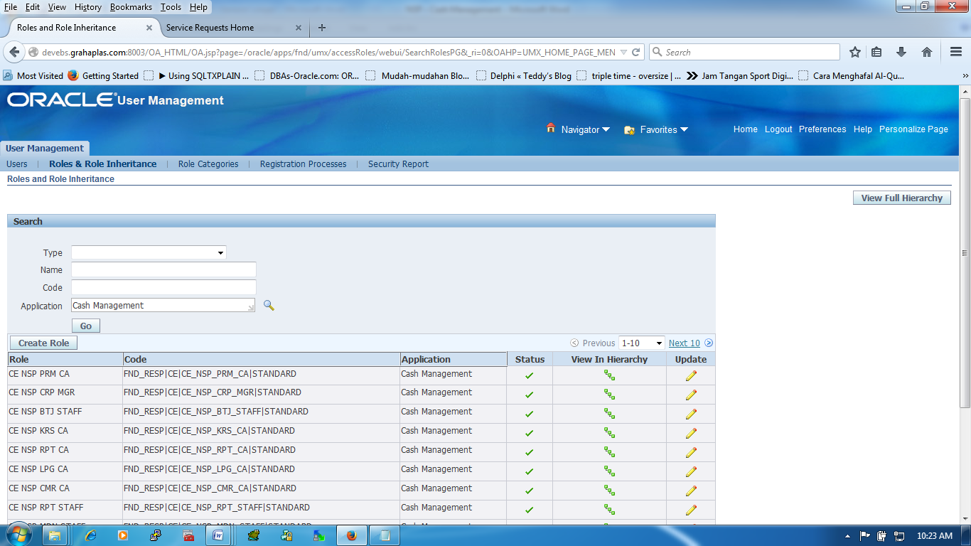Button 🡪 Update

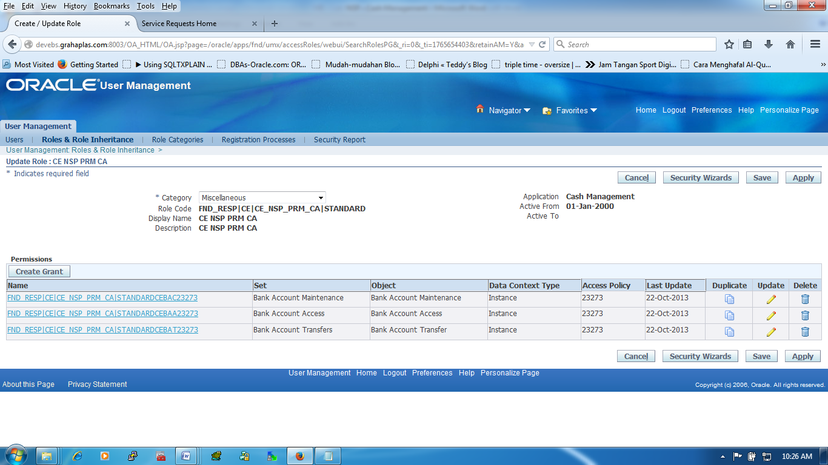

Button 🡪 Security Wizard

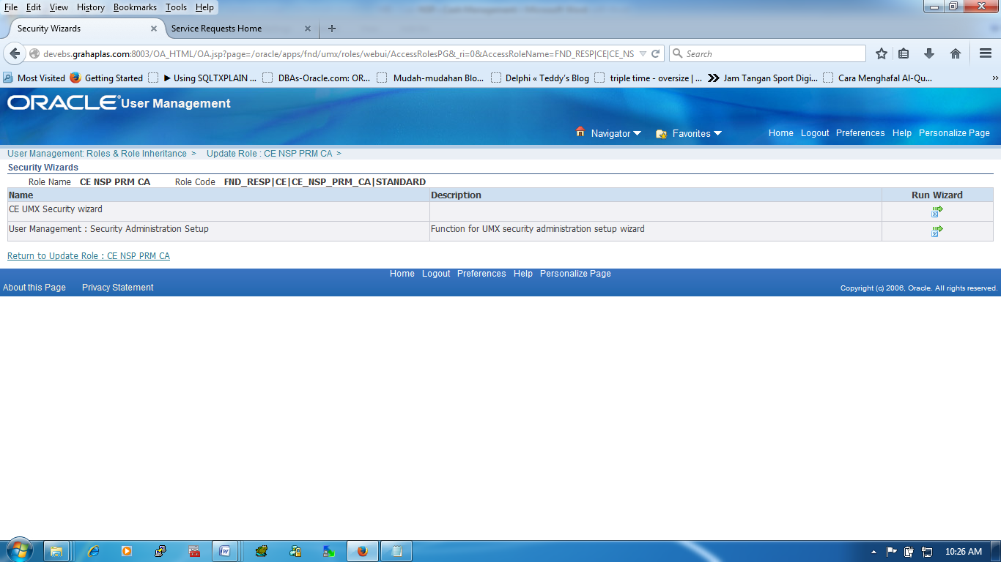

Button 🡪 Run Wizard (CE UMX Security Wizard)

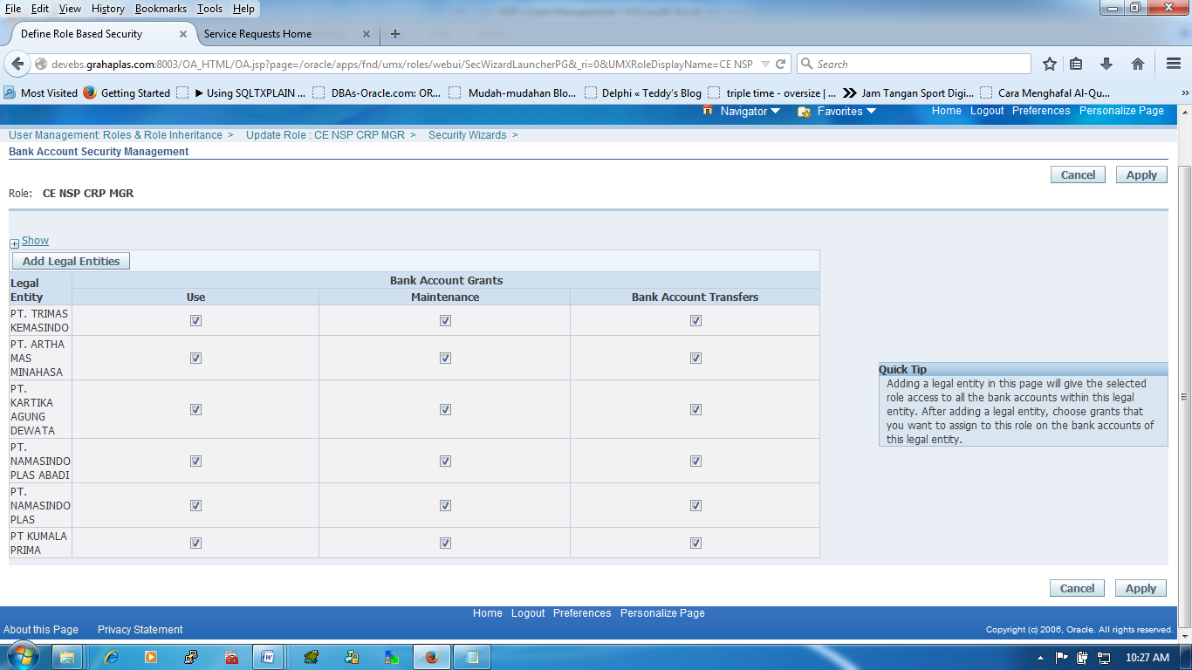

Button 🡪 Apply

|  |  |  |
| --- | --- | --- |
| User | : | Yes |
| Maintenance | : | Yes |
| Bank Account Transfer | : | Yes |

|  |  |  |
| --- | --- | --- |
| **Note** | **:** | **Assisgn nama LE baru di MOAC Security (Jalanin Concurrent "Security List Maintenance" Isi Parameters Dengan "All Security Profiles"** |

